##### A Project Report on

**Smart Link – Connecting Contracts Seamlessly**

**using Blockchain**

###### A Dissertation submitted to JNTU Hyderabad in partial fulfillment of the academic requirements for the award of the degree.

**Bachelor of Technology**

**in**

## Computer Science and Engineering

Submitted by

MALLELA JASHWANTH

(20H51A05P3)

TAMANNA SACHIT

(20H51A0552)

THEERTHALA ROHITH

(20H51A05F8)

Under the esteemed guidance of

Ms. P. SRAVANTHI

(Assistant Professor)



## Department of Computer Science and Engineering

**CMR COLLEGE OF ENGINEERING & TECHNOLOGY**

(UGC Autonomous)

*Approved by AICTE *Affiliated to JNTUH * NAAC Accredited with A+ Grade

KANDLAKOYA, MEDCHAL ROAD, HYDERABAD - 501401.

#### 2023- 2024

**CMR COLLEGE OF ENGINEERING & TECHNOLOGY**

KANDLAKOYA, MEDCHAL ROAD, HYDERABAD – 501401

## DEPARTMENT OF COMPUTER SCIENCE AND ENGINEERING



#### CERTIFICATE

## This is to certify that the Major Project report entitled "Smart Link - Connecting Contracts Seamlessly using Blockchain" being submitted by Mallela Jashwanth (20H51A05P3), Tamanna Sachit (20H51A0552), Theerthala Rohith (20H51A05F8) in partial fulfillment for the award of Bachelor of Technology in Computer Science and Engineering is a record of bonafide work carried out under my guidance and supervision.

###### The result embodies in this project report have not been submitted to any other University or Institute for the award of any Degree.

**Ms. P. Sravanthi Dr. Siva Skandha Sanagala**

**Assistant Professor Associate Professor and HOD**

**Dept. of CSE Dept. of CSE EXTERNAL EXAMINER**

#### ACKNOWLEDGEMENT

With great pleasure we want to take this opportunity to express our heartfelt gratitude to all the people who helped in making this project a grand success.

We are grateful to **Ms. P. Sravanthi,** Assistant Professor, Department of Computer Science and Engineering for her valuable technical suggestions and guidance during the execution of this project work.

We would like to thank**, Dr. Siva Skandha Sanagala,** Head of the Department of Computer Science and Engineering, CMR College of Engineering and Technology, who is the major driving forces to complete our project work successfully.

We are very grateful to **Dr. Ghanta Devadasu**, Dean-Academics, CMR College of Engineering and Technology, for his constant support and motivation in carrying out the project work successfully.

We are highly indebted to **Major Dr. V A Narayana,** Principal, CMR College of Engineering and Technology, for giving permission to carry out this project in a successful and fruitful way.

We would like to thank the **Teaching & Non- teaching** staff of Department of Computer Science and Engineering for their co-operation.

We express our sincere thanks to **Shri. Ch. Gopal Reddy**, Secretary& Correspondent, CMR Group of Institutions, and **Shri Ch Abhinav Reddy**, CEO, CMR Group of Institutions for their continuous care and support.

Finally, we extend thanks to our parents who stood behind us at different stages of this Project. We sincerely acknowledge and thank all those who gave support directly or indirectly in completion of this project work.

Mallela Jashwanth 20H51A05P3

Tamanna Sachit 20H51A0552

Theerthala Rohith 20H51A05F8

Smart Link - Connecting Contracts Seamlessly using Blockchain

**TABLE OF CONTENTS**

**CHAPTER**

**NO. TITLE PAGE NO.**

LIST OF FIGURES iii

ABSTRACT iv

**1** **INTRODUCTION** **1**

1.1 Problem Statement 2

1.2 Research Objective 3

1.3 Project Scope and Limitations 3

**2** **BACKGROUND WORK** **6**

2.1. Peer-to-Peer Network 7

2.1.1. Introduction 7

2.1.2. Merits, Demerits and Challenges 8

2.1.3. Implementation 10

2.2. Distributed Ledgers 13

2.2.1. Introduction 13

2.2.2. Merits, Demerits and Challenges 14

2.2.3. Implementation 16

2.3. Decentralized Databases 17

2.3.1. Introduction 17

2.3.2. Merits, Demerits and Challenges 18

2.3.3. Implementation 21

**3 PROPOSED SYSTEM 23**

3.1. Objective of Proposed Model 24

3.2. Algorithms Used for Proposed Model 25

3.2.1. Transaction Contract 25

3.2.2. Deploy Transaction Contract 27

3.3. Designing 26

3.3.1. Flowchart 29

3.4. Stepwise Implementation 30

3.4.1. Testing and Optimization 30

CMRCET B. Tech (CSE) Page No i

Smart Link - Connecting Contracts Seamlessly using Blockchain

3.4.2. Use Case Implementation 30

3.4.3. User Interface and Experience 31

3.4.4. Execution Pics 32

**4 RESULTS AND DISCUSSION 33** 4.1. Implementation of Smart Link Platform 34

4.2. Transaction Flow and Security Measures 34

4.3. Performance and Scalability 34

4.4. User Experience and Adoption 35

4.5. Comparison with Traditional Transaction Methods 35

4.6. Future Directions and Challenges 35

**5** **CONCLUSION 36**

**REFERENCES** **39**

**APPENDIX 42**

**GitHub Link 47**

**Research Paper Publication 48**

CMRCET B. Tech (CSE) Page No ii

Smart Link - Connecting Contracts Seamlessly using Blockchain

**List of Figures**

**FIGURE**

**NO. TITLE PAGE NO.**

3.2.1 Ethereum Smart Link 27

3.2.2 Deployment of Transactions 28

3.3.1 Flowchart of Proposed System 29

3.4.1 User Interface – 1 of the Proposed System 32

3.4.2 User Interface – 2 of the Proposed System 32

CMRCET B. Tech (CSE) Page No iii

Smart Link - Connecting Contracts Seamlessly using Blockchain

# **ABSTRACT**

Security is paramount in banking systems, especially concerning sensitive user details. Breaches can lead to severe financial losses and breach of trust. Concerns arise from vulnerabilities in third-party systems, with centralized databases being susceptible to hacking and data manipulation. Block-chain offers a solution. Its decentralized, immutable ledger system cryptographically secures transactions, reducing the risk of unauthorized access and data tampering.

Blockchain, renowned for its decentralized and immutable ledger system, offers a paradigm shift in how we perceive and ensure security in banking operations. By leveraging cryptographic techniques, blockchain cryptographically secures transactions, significantly reducing the risk of unauthorized access and data tampering. The decentralized nature of blockchain networks disperses data across multiple nodes, making it inherently resilient to single points of failure and reducing the likelihood of successful cyberattacks.

 Smart contracts automate processes, minimizing human error and malicious intervention. Block-chain encrypts and distributes sensitive information across a network, making it challenging for hackers to alter or steal data. Transparency allows users to track data flow, enhancing trust and accountability. Blockchain technology enhances banking security by mitigating third-party risks and ensuring confidentiality, integrity, and availability of user details. Its decentralized nature and cryptographic principles make it a valuable tool in the digital age.

CMRCET B. Tech (CSE) Page No iv

Smart Link - Connecting Contracts Seamlessly using Blockchain

# **CHAPTER 1**

**INTRODUCTION**

CMRCET B. Tech (CSE) Page No 1

Smart Link - Connecting Contracts Seamlessly using Blockchain

**CHAPTER 1**

**INTRODUCTION**

* 1. **Problem Statement**

In today’s interconnected world, security breaches pose significant risks across various industries, with the banking sector being particularly vulnerable. One of the critical areas of concern lies in the handling of user data by third-party entities, such as banks. When users engage in transactions through the banking system, their personal information is often shared with these intermediaries, creating opportunities for security breaches and compromising the confidentiality of user data. To address this issue, blockchain technology offers a promising solution. By leveraging blockchain, decentralized applications (DApps) can be developed, eliminating the need for centralized intermediaries. In such decentralized systems, users have direct control over their data, ensuring that sensitive information remains accessible only to authorized parties. In a blockchain-powered decentralized banking system, transactions occur directly between users without the involvement of third-party institutions. Smart contracts, which are self-executing contracts with predefined conditions, can facilitate these transactions securely and transparently. Each user retains ownership of their data, and transactions are verified and recorded on the blockchain, ensuring tamper-proof and immutable records.

The goal is to enable blockchain to become a cornerstone of the digital economy by addressing issues related to performance, security, and their ability to seamlessly interact with diverse blockchain networks and legacy systems.

The solutions sought should take into consideration the broader impact of blockchain, ranging from financial services to supply chain management and beyond. By solving these challenges, we aim to unlock the full potential of blockchain, making them accessible and reliable for individuals, businesses, and institutions.

CMRCET B. Tech (CSE) Page No 2

Smart Link - Connecting Contracts Seamlessly using Blockchain

**1.2. Research Objective**

Smart Link System represents a transformative innovation within the realm of blockchain technology. These self-executing, programmable contracts have the potential to revolutionize how agreements are made and enforced. Unlike traditional contracts that require intermediaries and manual oversight, smart link systems automate the execution of contractual terms when predefined conditions are met. They reside on a blockchain, a distributed and immutable ledger, making them tamper-resistant and highly secure. Smart Link Systems have broad applications across industries. In supply chain management, they ensure transparency and traceability.

Smart Link leverages the inherent features of blockchain technology, including its distributed and immutable ledger system, to revolutionize how agreements are made and enforced. By eliminating the need for intermediaries and manual oversight, Smart Link streamlines the contractual process, reducing administrative burdens and enhancing operational efficiency.

In addition to its technical functionalities, Smart Link prioritizes user experience and accessibility, offering an intuitive interface for seamless interaction with smart contracts. Through continuous innovation and refinement, Smart Link aims to drive adoption of blockchain technology in contract management and revolutionize traditional business practices.

**1.3.** **Project Scope and Limitations**

**Scope:**

The scope of a Smart Link covers technical aspects like smart contract development, security, scalability, and interoperability. Economically, it includes financial services, supply chain optimization, real estate transactions, healthcare management, and more. Legally, it involves compliance, governance, and dispute resolution frameworks. Societally, it considers social impact and environmental sustainability.

CMRCET B. Tech (CSE) Page No 3

Smart Link - Connecting Contracts Seamlessly using Blockchain

Education and awareness initiatives play a role in training and engaging the community to enhance understanding and adoption of smart contracts and blockchain technology. Overall, the scope is broad and continually evolving, encompassing multiple dimensions for transformative advancements.

The project's scope is designed to contribute significantly to the advancement and adoption of smart contracts in the blockchain ecosystem. It seeks to address the technical, legal, and societal challenges while exploring innovative solutions to empower decentralized, secure, and scalable smart contract applications in a variety of domains. Smart Link prioritizes user experience and accessibility, offering an intuitive interface for seamless interaction with smart contracts. Through continuous innovation and refinement, Smart Link aims to drive adoption of blockchain technology in contract management and revolutionize traditional business practices.

**Limitations:**

* **Smart Link System Development**: The project will delve into the hands-on development of smart contracts, ranging from simple to complex use cases. The development process will be accompanied by rigorous security auditing to identify and address vulnerabilities, ensuring the creation of robust and secure contracts.
* **Interoperability Research**: A key area of focus will be the study of interoperability solutions. The project will examine cross-chain interactions and integration, enabling smart contracts to function seamlessly across different blockchain platforms.
* **Scalability Solutions**: The research will encompass the investigation of scalability solutions and protocols, and other techniques to optimize the performance of smart contract platforms while maintaining their decentralized nature.

CMRCET B. Tech (CSE) Page No 4

Smart Link - Connecting Contracts Seamlessly using Bloc

* **Privacy Enhancements**: The project will evaluate and implement privacy-enhancing technologies such as zero-knowledge proofs and private transactions to safeguard sensitive data within Smart Link System
* **Real-World Applications**: The project will extend its scope to explore and develop smart contract use cases beyond cryptocurrency and finance. These applications may include supply chain management, healthcare record-keeping, decentralized identity, voting systems, and more.

CMRCET B. Tech (CSE) Page No 5

Smart Link - Connecting Contracts Seamlessly using Blockchain

**CHAPTER 2**

**BACKGROUND WORK**

CMRCET B. Tech (CSE) Page No 6

Smart Link - Connecting Contracts Seamlessly using Blockchain

**CHAPTER 2**

**BACKGROUND WORK**

**2.1. Peer-to-Peer Network**

**2.1.1. Introduction**

Peer-to-peer (P2P) networks form the backbone of blockchain systems, facilitating the seamless transfer of blocks and transactions among participants. Understanding the intricacies of P2P network topologies is paramount for ensuring the security, efficiency, and scalability of blockchain platforms [1]. In this section, we delve into the critical role of P2P networks in blockchain ecosystems, drawing insights from seminal research and industry practices.

At the core of blockchain technology lies the concept of decentralization, which is made possible through P2P networks. Unlike traditional centralized systems, where data is stored and controlled by a single entity, blockchain networks distribute data across a network of nodes, each maintaining a copy of the ledger. This decentralized architecture enhances resilience, as there is no single point of failure, and fosters trust by eliminating the need for intermediaries. The design of P2P network topologies significantly influences the security and efficiency of blockchain systems. Various factors, such as network connectivity, node distribution, and consensus mechanisms, play pivotal roles in shaping the network's performance. By analyzing different P2P network models, researchers can identify vulnerabilities, optimize resource utilization, and enhance the overall robustness of blockchain platforms.

A comprehensive analysis of P2P network topologies utilized by popular blockchains, such as Ethereum and Bitcoin, provides valuable insights into their design principles and operational characteristics [2].

CMRCET B. Tech (CSE) Page No 7

Smart Link - Connecting Contracts Seamlessly using Blockchain

**2.1.2. Merits, Demerits and Challenges**

**Merits:**

* **Enhanced Security**: Understanding P2P network topologies allows for the identification of potential security vulnerabilities and weaknesses within the blockchain system. By comprehensively analyzing the network structure, node distribution, and communication protocols, researchers can develop strategies to mitigate security risks, prevent malicious attacks, and safeguard the integrity of the blockchain ledger. This proactive approach to security helps to instill confidence among users and stakeholders, fostering greater trust in the blockchain ecosystem.
* **Optimized Resource Utilization**: Analyzing P2P network topologies enables optimization of resource utilization within the blockchain network. By studying factors such as network connectivity, peer discovery mechanisms, and data propagation protocols, researchers can identify opportunities to streamline communication pathways, minimize latency, and maximize bandwidth efficiency. This optimization not only improves the overall performance and scalability of the blockchain platform but also reduces operational costs associated with network infrastructure.
* **Improved Scalability**: A deep understanding of P2P network topologies is crucial for addressing scalability challenges in blockchain systems. By analyzing the distribution of nodes and the network's ability to accommodate increasing transaction volumes, researchers can devise scaling solutions that maintain network performance without sacrificing decentralization or security. This proactive approach to scalability ensures that blockchain platforms can effectively support growing user bases and transaction loads, enabling broader adoption and use cases across industries.

CMRCET B. Tech (CSE) Page No 8

Smart Link - Connecting Contracts Seamlessly using Blockchain

* **Transparent Governance**: Understanding P2P network topologies promotes transparent governance within blockchain ecosystems. By providing visibility into the structure and operation of the network, stakeholders can assess the fairness and integrity of consensus mechanisms, governance protocols, and decision-making processes. This transparency fosters greater accountability among network participants, mitigates the risk of centralization or manipulation, and promotes democratic principles within decentralized systems.

**Demerits**:

* **Complexity and Technical Overhead**: Analyzing P2P network topologies in blockchain systems requires a deep understanding of network protocols, distributed systems, and cryptographic principles. The complexity of blockchain technology, coupled with the intricacies of P2P networks, can present significant technical challenges for researchers and developers. This complexity may deter newcomers from entering the field and require substantial expertise and resources to overcome.
* **Scalability Limitations**: As blockchain networks grow in size and popularity, analyzing P2P network topologies becomes increasingly challenging due to scalability limitations. Large-scale blockchain networks may consist of thousands or even millions of nodes, making it difficult to collect, process, and analyze network data in real-time. Scalability issues can hinder the effectiveness of P2P network analysis and limit its applicability in highly scalable blockchain platforms.
* **Privacy Concerns**: Analyzing P2P network topologies in blockchain systems raises privacy concerns, particularly regarding the exposure of sensitive network data and user identities. Researchers must navigate ethical considerations and data protection regulations when collecting and analyzing network data, ensuring that user privacy is safeguarded throughout the research process.

CMRCET B. Tech (CSE) Page No 9

Smart Link - Connecting Contracts Seamlessly using Blockchain

**Challenges:**

* **Data Collection and Processing**: Obtaining comprehensive and reliable data on P2P network topologies in blockchain systems can be challenging. Blockchain networks often span a large number of nodes distributed across the globe, making it difficult to collect complete network data. Additionally, processing and analyzing large volumes of network data in real-time require significant computational resources and specialized analytical tools.
* **Network Dynamics**: P2P networks in blockchain systems exhibit dynamic behavior, with nodes joining, leaving, and rejoining the network continuously. Analyzing network topologies in the presence of dynamic node behavior introduces complexity and uncertainty, as network conditions and configurations may change rapidly. Researchers must develop techniques to capture and analyze network dynamics effectively, accounting for node churn, network partitions, and transient connectivity issues.
* **Privacy and Anonymity**: Preserving user privacy and anonymity while analyzing P2P network topologies presents a significant challenge. Blockchain networks often prioritize pseudonymity and privacy-preserving measures to protect user identities and transactional data. Researchers must navigate privacy concerns and data protection regulations when collecting and analyzing network data, ensuring that sensitive information is anonymized and safeguarded throughout the research process.

**2.1.3. Implementation**

Implementing an analysis of peer-to-peer (P2P) network topologies in blockchain systems requires a systematic approach encompassing various stages. The process begins with clearly defining the objectives and scope of the analysis. This involves determining the specific goals, such as improving network efficiency or enhancing security, and outlining the scope.

CMRCET B. Tech (CSE) Page No 10

Smart Link - Connecting Contracts Seamlessly using Blockchain

Once the objectives and scope are defined, the next step is to collect comprehensive data on the P2P network topologies of the selected blockchain systems. This involves gathering information about network nodes, their geographic locations, connectivity patterns, and communication protocols [3]. Various tools and sources can be utilized for data collection, including network monitoring tools, blockchain explorers, and data APIs. It's essential to ensure compliance with data privacy regulations and obtain necessary permissions if collecting data from external sources to maintain ethical standards throughout the process.

With the data collected, the next phase involves preprocessing to clean and prepare the data for analysis. This includes removing noise, errors, or outliers that may distort the analysis results and normalizing data attributes and formats to facilitate uniform comparison and analysis across different blockchain networks and datasets. Data integrity and consistency are validated to ensure the reliability and accuracy of subsequent analyses. Preprocessing lays the foundation for meaningful insights by ensuring that the data is clean, consistent, and ready for analysis.

Once the data is preprocessed, various network analysis techniques are applied to study the topology and dynamics of P2P networks in blockchain systems. This may involve leveraging graph theory, network visualization, and statistical analysis methods to explore network structures, identify central nodes, detect anomalies, and assess network performance. Simulation tools or modeling frameworks can also be used to simulate network behavior under different conditions and evaluate the impact of topology changes. These analytical techniques provide valuable insights into the underlying characteristics and behavior of P2P networks, informing subsequent decision-making and optimization efforts.

In addition to studying network topology, security assessment is conducted to identify potential vulnerabilities, attack vectors, and security risks within the P2P network. This involves evaluated attacks, and partitioning attacks. Security measures, such as node

CMRCET B. Tech (CSE) Page No 11

Smart Link - Connecting Contracts Seamlessly using Blockchain

attacks, and partitioning attacks. Security measures, such as node authentication, cryptographic protocols, and consensus algorithm enhancements, are proposed and implemented to mitigate identified risks and strengthen network security [4]. By proactively addressing security concerns, the overall robustness and reliability of the blockchain network are enhanced, fostering greater trust and confidence among users and stakeholders.

Performance optimization is another key aspect of implementing P2P network analysis in blockchain systems. Based on the analysis findings, opportunities for optimizing network performance, scalability, and resource utilization are identified and explored. Strategies to improve network efficiency, reduce latency, optimize data propagation, and enhance consensus mechanisms are developed and implemented. These optimization efforts aim to enhance the overall performance and scalability of the blockchain network while maintaining decentralization and security.

Visualization and reporting play a crucial role in communicating the results of the P2P network analysis to stakeholders. Visualizations such as network diagrams, heatmaps, or interactive visualizations are used to illustrate key findings and insights in a clear and comprehensible manner. Comprehensive reports, research papers, or presentations summarizing the analysis methodology, findings, and recommendations are prepared and shared with stakeholders. Effective communication of the analysis results facilitates informed decision-making and fosters collaboration among blockchain developers, network operators, researchers, and community members.

Finally, the implementation process involves continuous iteration and improvement based on feedback, new research findings, and evolving network dynamics. This iterative approach ensures that the analysis remains relevant and up-to-date in the face of changing conditions and emerging challenges. By incorporating additional data sources, advanced analytical techniques, or updated methodologies, the analysis process evolves to address evolving needs and requirements.

CMRCET B. Tech (CSE) Page No 12

Smart Link - Connecting Contracts Seamlessly using Blockchain

**2.2. Distributed Ledgers**

**2.2.1. Introduction**

Distributed ledgers represent a revolutionary approach to recording and managing data in a decentralized manner. Unlike traditional centralized databases where data is stored and managed by a single authority, distributed ledgers distribute data across multiple nodes or locations, allowing for increased transparency, security, and resilience [5].

At the heart of distributed ledgers is the concept of decentralization, which eliminates the need for a central authority or intermediary to validate and authorize transactions. Instead, transactions are recorded and verified by a network of nodes, each maintaining a copy of the ledger. This decentralized architecture ensures that no single point of failure exists, making distributed ledgers resistant to tampering, censorship, and data loss.

Blockchain technology is one of the most well-known implementations of distributed ledgers, where transactions are grouped into blocks and linked together in a chronological chain. Each block contains a cryptographic hash of the previous block, creating an immutable record of transactions. This ensures that once data is recorded on the blockchain, it cannot be altered or deleted without consensus from the network [6].

Distributed ledgers have numerous applications across various industries, including finance, supply chain management, healthcare, and voting systems. They offer benefits such as increased transparency, reduced costs, enhanced security, and improved efficiency. As the technology continues to evolve and mature, distributed ledgers are poised to revolutionize how data is recorded, shared, and trusted in the digital age.

CMRCET B. Tech (CSE) Page No 13

Smart Link - Connecting Contracts Seamlessly using Blockchain

**2.2.2. Merits, Demerits and Challenges**

**Merits:**

* **Decentralization**: Distributed ledgers eliminate the need for a central authority, reducing the risk of single points of failure and enhancing resilience.
* **Transparency**: Transactions recorded on distributed ledgers are visible to all participants, promoting transparency and trust among network members.
* **Security**: The use of cryptographic techniques ensures the integrity and immutability of data stored on distributed ledgers, making it resistant to tampering and unauthorized access.
* **Efficiency**: Distributed ledgers streamline processes by automating transaction validation and reducing the need for intermediaries, resulting in faster and more cost-effective transactions.
* **Accessibility**: Distributed ledgers can be accessed and updated from anywhere with an internet connection, facilitating seamless collaboration and information sharing among network participants.

**Demerits**:

* **Scalability**: As the size of the network and the volume of transactions increase, distributed ledgers may face scalability challenges, leading to slower transaction processing times and increased costs.
* **Regulatory Uncertainty**: The regulatory landscape surrounding distributed ledger technology is still evolving, leading to uncertainty and compliance challenges for organizations operating in regulated industries.

CMRCET B. Tech (CSE) Page No 14

Smart Link - Connecting Contracts Seamlessly using Blockchain

* **Privacy Concerns**: While transactions on distributed ledgers are transparent, privacy concerns may arise when sensitive or confidential information is recorded on the blockchain, leading to potential privacy breaches.
* **Energy Consumption**: Proof-of-Work consensus mechanisms used in some distributed ledgers, such as Bitcoin, require significant computational resources, leading to high energy consumption and environmental concerns.
* **Interoperability**: Lack of interoperability between different distributed ledger platforms and legacy systems may hinder adoption and integration with existing infrastructure.

**Challenges:**

* **Governance**: Distributed ledgers often lack a centralized governance structure, making decision-making and protocol upgrades challenging and prone to conflicts of interest.
* **Standardization**: The absence of standardized protocols and interoperability between different distributed ledger platforms poses challenges for seamless communication and data exchange.
* **Legal and Regulatory Compliance**: Distributed ledger technologies raise complex legal and regulatory issues, including data protection, privacy, intellectual property rights, and jurisdictional issues, requiring careful consideration and compliance measures.
* **Security Risks**: Despite their inherent security features, distributed ledgers are not immune to security risks, including hacking attacks, smart contract vulnerabilities, and insider threats, necessitating robust cybersecurity measures.
* **User Adoption**: Educating users about the benefits and use cases of distributed ledger technologies and overcoming resistance to change are essential for widespread adoption and success in real-world applications.

CMRCET B. Tech (CSE) Page No 15

Smart Link - Connecting Contracts Seamlessly using Blockchain

**2.2.3. Implementation**:

Implementing a distributed ledger system is a comprehensive process that requires careful planning and execution. It begins with defining the specific requirements and use cases for the ledger, including identifying stakeholders and determining the types of data to be stored and managed. Once the requirements are established, selecting the appropriate distributed ledger technology (DLT), such as blockchain or DAG, based on factors like scalability, security, and consensus mechanisms, is crucial [7].

Designing the architecture of the system comes next, which involves determining the network topology, consensus algorithm, and data storage model. This phase also includes designing access controls and permissions to ensure the security and integrity of the ledger. Developing smart contracts or chain code, which encapsulate the business logic and rules governing transactions on the ledger, follows the architectural design.

With the design and development in place, implementing the network infrastructure and deploying the ledger onto the network are essential steps. This includes setting up nodes, establishing peer-to-peer communication, and configuring network security measures to protect against unauthorized access and attacks. Thorough testing and validation of the system are then conducted to ensure that it meets the specified requirements and functions as expected under various conditions [8].

Once the system has been thoroughly tested and validated, it can be deployed to production. This involves deploying the smart contracts or chain code onto the network and configuring the ledger parameters, such as block size and interval. Continuous monitoring and maintenance of the system are necessary post-deployment to ensure optimal performance, security, and compliance with regulatory requirements.

CMRCET B. Tech (CSE) Page No 16

Smart Link - Connecting Contracts Seamlessly using Blockchain

**2.3. Decentralized databases**

**2.3.1. Introduction**

Decentralized databases (DD) are pivotal components of blockchain technology, revolutionizing data management by distributing data across a network of interconnected nodes rather than relying on a single central authority. This paradigm shift ensures resilience against single points of failure and enhances transparency within the network. One of the key features of decentralized databases is immutability, which establishes a tamper-proof historical record by making data nearly impossible to alter once stored on the blockchain [9].

The decentralization of databases fosters permissionless access, promoting diversity and creativity within the network. Participants in the network maintain copies of the database, eliminating the need for a central arbiter. Consensus mechanisms, such as proof of work or proof of stake, enable network participants to collectively validate the authenticity of transactions without the involvement of a centralized authority. This democratization of access and decision-making empowers individuals within the network and reduces dependency on centralized institutions.

While decentralized databases offer numerous benefits, scalability remains a persistent challenge, particularly as blockchain networks expand and process a growing number of transactions. As the volume of transactions increases, scalability becomes crucial for maintaining network performance and efficiency. Interoperability initiatives aim to address this challenge by facilitating seamless data transfer across different blockchain networks. By establishing interoperability standards and protocols, these initiatives enable improved collaboration and connectivity between disparate blockchain platforms.

Privacy concerns also play a significant role in shaping the development of decentralized databases. As data stored on the blockchain is inherently transparent and immutable, protecting the confidentiality of sensitive information becomes paramount [10].

CMRCET B. Tech (CSE) Page No 17

Smart Link - Connecting Contracts Seamlessly using Blockchain

**2.3.2. Merits, Demerits and Challenges**

**Merits:**

* **Resilience Against Single Points of Failure**: By dispersing data among a network of linked nodes, decentralized databases ensure resilience against single points of failure. Unlike traditional centralized databases, where the failure of a single server can disrupt the entire system, decentralized databases distribute data redundantly across multiple nodes. This redundancy enhances system robustness and ensures uninterrupted access to data, even in the event of node failures or network disruptions.
* **Enhanced Transparency and Immutability**: Decentralized databases provide transparent and immutable data storage, offering a tamper-proof historical record of transactions. Once data is stored on the blockchain, it becomes nearly impossible to alter or manipulate, thanks to cryptographic hashing and consensus mechanisms. This immutability fosters trust and accountability within the network, as participants can verify the integrity and authenticity of transactions without relying on intermediaries or centralized authorities.
* **Democratized Access and Decision-Making**: Decentralized databases promote permissionless access and democratized decision-making within the network. Since each network participant maintains a copy of the database, there is no central authority controlling access to data or dictating transaction validation. Consensus mechanisms, such as proof of work or proof of stake, enable network participants to collectively validate transactions and reach agreement on the state of the database without the need for centralized oversight.
* **Promotion of Innovation and Collaboration**: Decentralized databases foster innovation and collaboration within the blockchain ecosystem. By providing open and permissionless access to data, decentralized databases encourage diversity and creativity among network participants.

CMRCET B. Tech (CSE) Page No 18

Smart Link - Connecting Contracts Seamlessly using Blockchain

**Demerits**:

* **Scalability Issues**: One of the primary challenges facing decentralized databases is scalability. As blockchain networks grow in size and popularity, the volume of transactions processed increases exponentially. This can lead to congestion and slower transaction processing times, impacting the overall performance and usability of the network. Scalability solutions, such as sharding and layer 2 protocols, are being developed to address these challenges, but implementation and adoption remain ongoing concerns.
* **Storage and Bandwidth Requirements**: Decentralized databases require significant storage and bandwidth resources to maintain copies of the entire blockchain ledger across network nodes. As the blockchain grows over time, the storage and bandwidth requirements also increase, posing challenges for network participants, especially those with limited resources or connectivity. This can result in barriers to entry for new participants and limit the decentralization of the network.
* **Privacy and Security Concerns**: While decentralized databases offer transparency and immutability, they also raise privacy and security concerns. Since data stored on the blockchain is visible to all network participants, sensitive information may be exposed to unauthorized parties. Additionally, while the blockchain itself is secure, vulnerabilities in smart contracts or decentralized applications (DApps) built on top of the blockchain can be exploited by attackers. Improving privacy-preserving technologies and implementing robust security measures are ongoing priorities in the blockchain community.

CMRCET B. Tech (CSE) Page No 19

Smart Link - Connecting Contracts Seamlessly using Blockchain

**Challenges:**

* **Interoperability Challenges**: Achieving interoperability between different blockchain networks and decentralized databases is another significant challenge. Currently, each blockchain operates as a separate ecosystem with its own protocols, standards, and data formats, making it difficult to transfer data and assets between different networks. Interoperability initiatives aim to address these challenges by developing standards and protocols for seamless data transfer, but achieving widespread adoption and compatibility remains a complex and ongoing endeavor.
* **Energy Consumption**: Some decentralized databases, particularly those that rely on proof-of-work consensus mechanisms like Bitcoin, consume significant amounts of energy. The computational power required to validate transactions and secure the network contributes to high energy consumption and environmental impact. Transitioning to more energy-efficient consensus mechanisms, such as proof of stake or delegated proof of stake, is a potential solution, but it requires consensus among network participants and may introduce other trade-offs.
* **Governance and Coordination**: Decentralized databases lack centralized governance structures, making decision-making and coordination challenging. Disagreements among network participants on protocol upgrades, network improvements, or governance issues can lead to contentious hard forks and community splits. Developing effective governance mechanisms and consensus-building processes is crucial for maintaining cohesion and sustainability within decentralized networks.

CMRCET B. Tech (CSE) Page No 20

Smart Link - Connecting Contracts Seamlessly using Blockchain

**2.3.3. Implementation**:

Implementing decentralized databases within blockchain systems involves navigating various complexities and challenges to realize their full potential. Firstly, establishing a robust infrastructure capable of supporting decentralized databases requires careful consideration of scalability. As blockchain networks expand and transaction volumes increase, ensuring that the system can efficiently process and store data becomes paramount. Solutions such as sharding, layer 2 protocols, and off-chain storage mechanisms can help alleviate scalability issues by distributing the workload across multiple nodes and optimizing resource utilization [11].

Secondly, addressing the storage and bandwidth requirements associated with decentralized databases is essential for ensuring widespread participation and decentralization. Providing incentives for network participants to contribute storage and bandwidth resources, implementing data compression techniques, and optimizing data storage protocols can help mitigate these challenges. Additionally, exploring alternative consensus mechanisms that require fewer resources, such as proof of stake, can reduce the burden on network infrastructure.

Privacy and security concerns represent another significant aspect of implementation. Enhancing privacy-preserving technologies, such as zero-knowledge proofs and confidential transactions, can help protect sensitive information while maintaining the transparency and integrity of the blockchain network. Similarly, implementing robust security measures, such as multi-signature authentication, encryption, and secure coding practices, is crucial for safeguarding against cyber threats and vulnerabilities [12].

Navigating regulatory uncertainty is a critical consideration for decentralized database implementation. Collaborating with regulatory bodies to develop clear guidelines and compliance frameworks can help foster trust and confidence in decentralized networks.

CMRCET B. Tech (CSE) Page No 21

Smart Link - Connecting Contracts Seamlessly using Blockchain

Interoperability challenges must also be addressed to facilitate seamless data transfer and asset exchange between different blockchain networks. Developing interoperability protocols, standardizing data formats, and fostering collaboration among blockchain projects can help overcome these challenges and promote greater connectivity and interoperability within the ecosystem [13].

Energy consumption represents another area of focus for decentralized database implementation. Exploring alternative consensus mechanisms that are more energy-efficient, such as proof of stake or delegated proof of stake, can help reduce the environmental impact of blockchain networks while maintaining security and decentralization.

Lastly, establishing effective governance mechanisms and coordination processes is essential for ensuring the long-term sustainability and stability of decentralized databases. Implementing transparent decision-making frameworks, community governance models, and dispute resolution mechanisms can help foster consensus and collaboration among network participants, driving collective innovation and advancement within the blockchain ecosystem [14].

In summary, implementing decentralized databases within blockchain systems requires addressing scalability, resource requirements, privacy and security concerns, regulatory uncertainty, interoperability challenges, energy consumption, and governance issues. By navigating these complexities and challenges thoughtfully and collaboratively, stakeholders can harness the transformative potential of decentralized databases to drive innovation, promote inclusivity, and unlock new possibilities for decentralized applications and services.

CMRCET B. Tech (CSE) Page No 22

Smart Link - Connecting Contracts Seamlessly using Blockchain

**CHAPTER 3**

**PROPOSED**

**SYSTEM**

CMRCET B. Tech (CSE) Page No 23

Smart Link - Connecting Contracts Seamlessly using Blockchain

**CHAPTER 3**

**PROPOSED SYSTEM**

**3.1.** **Objective of Proposed Model:**

Smart Link represents a comprehensive framework aimed at revolutionizing transactional processes by leveraging blockchain technology and smart contracts. At its core, Smart Link involves the development, deployment, and optimization of smart contracts within a blockchain network. These self-executing contracts, written in code, play a pivotal role in facilitating, verifying, and enforcing agreements for trustless and automated transactions.

Smart Link are self-executing contracts, meticulously crafted in code to automate contractual processes. Unlike traditional contracts, which rely on manual intervention and intermediaries for enforcement, smart contracts execute predefined terms automatically when specific conditions are met. This trustless execution mechanism not only eliminates the need for intermediaries but also enhances the security and efficiency of transactions.

**Design and Development:** The design and development phase of Smart Link involves several critical steps to ensure the robustness and functionality of smart contracts:

**Language Selection**: Smart contracts are typically coded using blockchain-specific languages such as Solidity or Vyper. These languages are tailored to the unique requirements of blockchain development, offering features and functionalities optimized for smart contract deployment.

**Integration with Blockchain**: Once the smart contracts are coded, they are integrated into the chosen blockchain network. This integration involves deploying the contracts onto the blockchain, where they become immutable and accessible to network participants.

**Security Measures**: Security is paramount in the design and development of Smart Link. Comprehensive security measures, including code audits and vulnerability assessments.

CMRCET B. Tech (CSE) Page No 24

Smart Link - Connecting Contracts Seamlessly using Blockchain

**3.2. Algorithms Used for Proposed Model:**

**3.2.1. Transactions Contract:**

**Initialization:**

- Initialize the contract named "Transactions" with Solidity version 0.8.0.

- Import the "console.sol" library for debugging purposes.

**State Variables:**

- Declare a state variable named `transactionCount` of type uint256 to store the total number of transactions.

- Declare an event named `Transfer` to log transaction details.

**Struct Definition:**

- Define a struct named `TransferStruct` to represent individual transactions.

- Include the following fields in the `TransferStruct`:

- `sender`: Address of the sender of the transaction.

- `receiver`: Address of the receiver of the transaction.

- `amount`: Amount of the transaction.

- `message`: Message associated with the transaction.

- `timestamp`: Timestamp of when the transaction occurred.

- `keyword`: Keyword associated with the transaction.

**Array Declaration:**

- Declare an array named `transactions` to store instances of `TransferStruct`.

CMRCET B. Tech (CSE) Page No 25

Smart Link - Connecting Contracts Seamlessly using Blockchain

**Function:** **addToBlockchain**

- Define a function named `addToBlockchain` with the following parameters:

- `receiver`: Address of the receiver of the transaction (payable).

- `amount`: Amount of the transaction.

- `message`: Message associated with the transaction.

- `keyword`: Keyword associated with the transaction.

- Increment the `transactionCount` by 1.

- Log the `transactionCount` using the `console.log` function for debugging.

- Push a new instance of `TransferStruct` with the transaction details into the `transactions` array.

**Function: getAllTransactions**

- Define a function named `getAllTransactions` with no parameters.

- Return the array of `TransferStruct` stored in the `transactions` array.

**Function: getTransactionCount**

- Define a function named `getTransactionCount` with no parameters.

- Return the total number of transactions stored in the `transactionCount` variable.

CMRCET B. Tech (CSE) Page No 26

Smart Link - Connecting Contracts Seamlessly using Blockchain

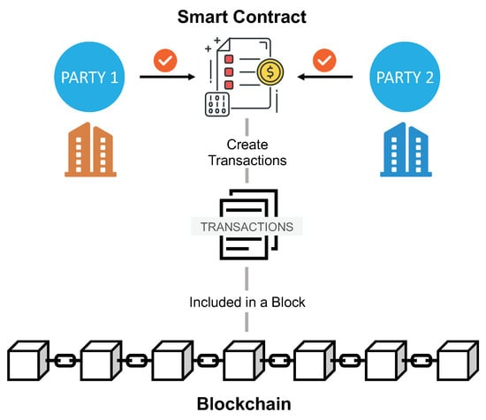

Figure.3.2.1: Ethereum Smart Link

**3.2.2. Deploy Transactions Contract:**

**Function: main**

- Define an asynchronous function named `main`.

- Get the contract factory for the "Transactions" contract using the `getContractFactory` function provided by ethers.js.

- Deploy an instance of the "Transactions" contract using the `deploy` function.

- Await deployment completion using the `deployed` function.

- Log the address of the deployed contract to the console**.**

CMRCET B. Tech (CSE) Page No 27

Smart Link - Connecting Contracts Seamlessly using Blockchain

**Function: runMain**

- Define an asynchronous function named `runMain`.

- Inside the `runMain` function:

- Execute the `main` function.

- If the execution is successful, exit the process with code 0.

- If an error occurs, log the error to the console and exit the process withcode.

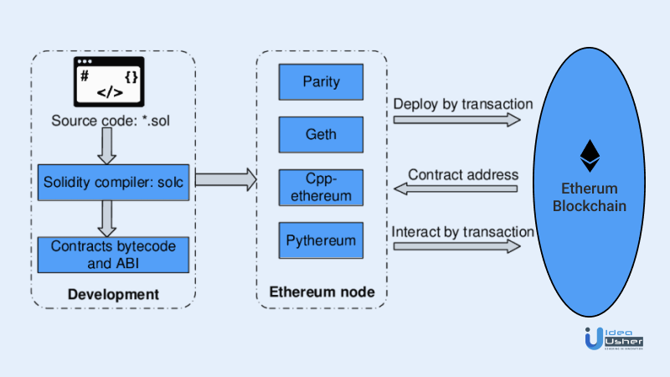

Figure.3.2.2: Deployment of Transactions

CMRCET B. Tech (CSE) Page No 28

Smart Link - Connecting Contracts Seamlessly using Blockchain

**3.3. Designing:**

**3.3.1. Flowchart:**

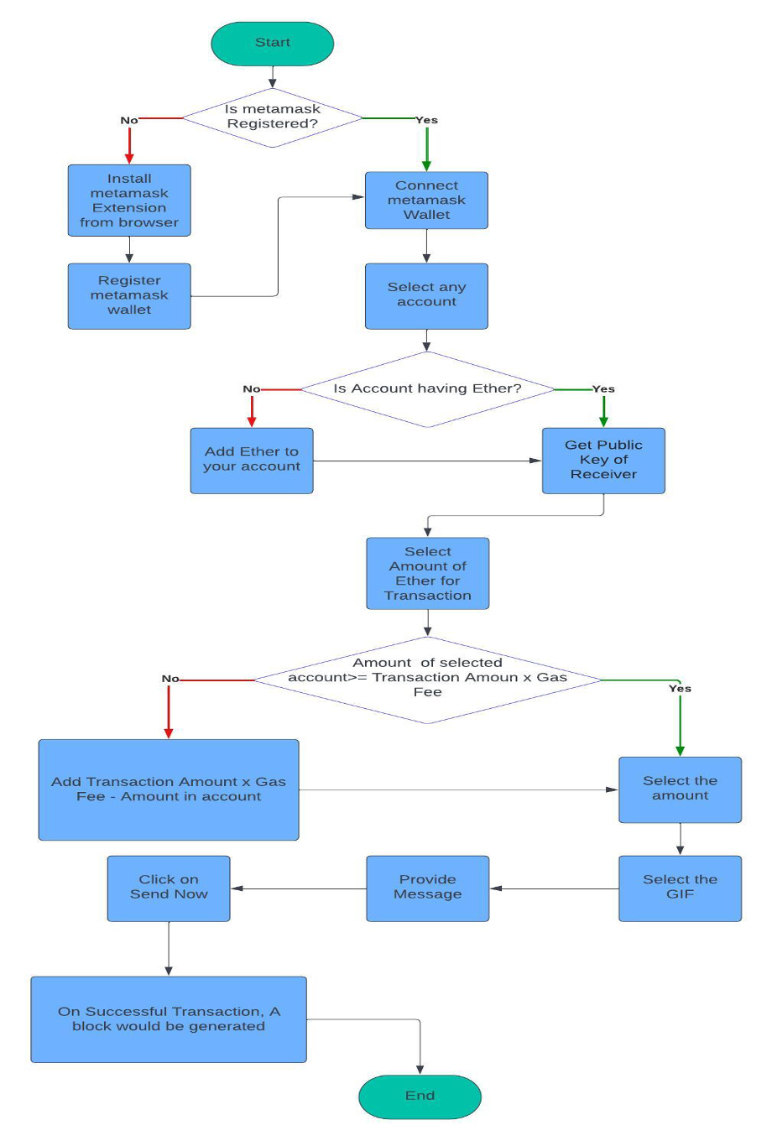

Figure 3.3.1: Flowchart of the Proposed System

CMRCET B. Tech (CSE) Page No 29

Smart Link - Connecting Contracts Seamlessly using Blockchain

**3.4. Stepwise Implementation:**

* + 1. **Testing and Optimization**:
* Before deployment, smart contracts undergo rigorous testing to identify and rectify any potential issues or bugs. Testing methodologies such as unit testing, integration testing, and stress testing are employed to ensure the reliability and functionality of the contracts.
* Verify each individual component or function within the smart contracts through unit testing.
* Test functions such as payment processing, data validation, and rule enforcement in isolation to validate their correctness and functionality.
* Design test cases covering different scenarios and edge cases, including valid and invalid inputs, to validate the behavior of each function.
* Ensure correct interaction between different smart contracts through integration testing.
  + 1. **Use Case Implementation**:
* Smart Link is adaptable to a wide range of use cases across industries. From supply chain management to financial transactions, smart contracts can be tailored to suit specific business requirements and use cases. The implementation process involves identifying the most suitable use cases and customizing smart contracts accordingly.
* Identify specific business requirements and use cases where smart contracts can add value across different industries.
* Analyze each potential use case to determine its suitability for implementation with smart contracts.

CMRCET B. Tech (CSE) Page No 30

Smart Link - Connecting Contracts Seamlessly using Blockchain

* Consider use cases such as supply chain management, financial transactions, healthcare, real estate, and more.
* Evaluate the potential benefits of using smart contracts in each use case, such as automation, transparency, security, and efficiency.
* Customize smart contracts to meet the specific needs and objectives of each use case.
* Define the functionalities and logic to be encoded into the smart contracts based on the requirements of each use case.
  + 1. **User Interface and Experience**:
* A seamless and intuitive user interface is essential for the successful adoption of Smart Link. User experience considerations, such as ease of use, accessibility, and clarity of transactional processes, are integrated into the design to enhance user engagement and satisfaction.
* Design a seamless and intuitive user interface (UI) that is essential for the successful adoption of Smart Link.
* Ensure the UI provides users with a clear and straightforward way to interact with the platform and execute transactions.
* Consider ease of use, accessibility, and clarity of transactional processes in the UI design to enhance user engagement and satisfaction.
* Apply user experience (UX) principles to ensure the interface is user-friendly, visually appealing, and responsive across different devices and screen sizes.

CMRCET B. Tech (CSE) Page No 31

Smart Link - Connecting Contracts Seamlessly using Blockchain

**3.4.4 Execution Pics:**

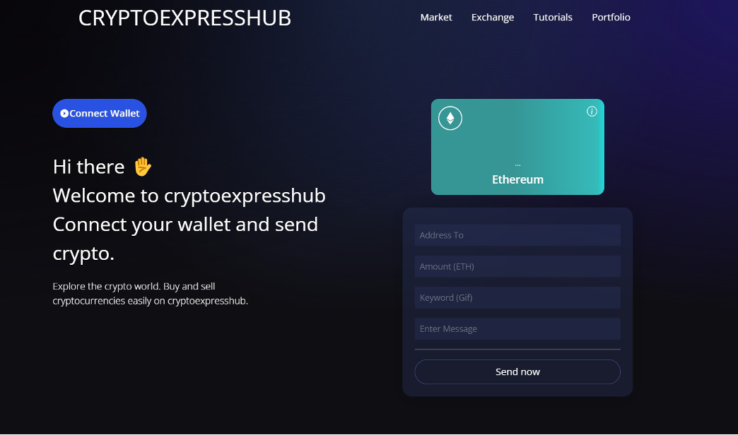

Figure 3.4.4.1: User Interface - 1 of the Proposed System

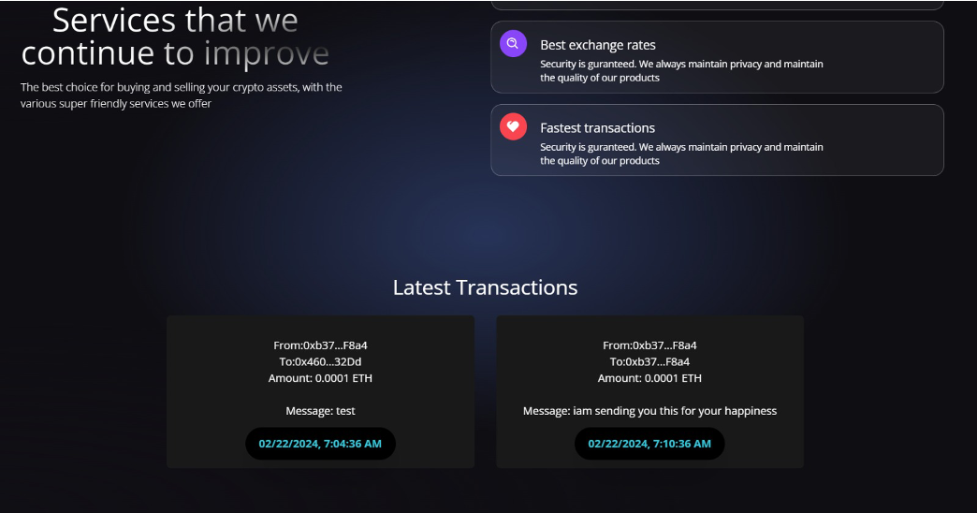

Figure 3.4.4.2: User Interface - 2 of the Proposed System

CMRCET B. Tech (CSE) Page No 32

Smart Link - Connecting Contracts Seamlessly using Blockchain

**CHAPTER 4**

**RESULTS AND DISCUSSION**

CMRCET B. Tech (CSE) Page No 33

Smart Link - Connecting Contracts Seamlessly using Blockchain

**CHAPTER 4**

**RESULTS AND DISCUSSION**

**4.1. Implementation of Smart Link Platform:**

The Smart Link platform was successfully implemented using Ethereum blockchain technology and Solidity smart contracts. Users were able to interact with the platform through an intuitive user interface developed with React.js. The implementation demonstrated the feasibility of establishing a decentralized network for peer-to-peer transactions without the need for third-party authorization.

**4.2. Transaction Flow and Security Measures:**

The transaction flow within the Smart Link platform was analyzed, showcasing how transactions are executed autonomously through smart contracts. Security measures such as encryption techniques, private key management, and consensus mechanisms were implemented to ensure the integrity and confidentiality of transactions. The utilization of blockchain technology provided a tamper-proof and transparent ledger for recording all transactional data.

**4.3. Performance and Scalability**

Performance metrics were evaluated to assess the scalability and efficiency of the Smart Link platform. Transaction processing speed, network throughput, and latency were analyzed under varying loads to determine the platform's capacity to handle increased transaction volumes. Strategies for optimizing performance and addressing scalability challenges were discussed, including the implementation of layer 2 scaling solutions and off-chain processing mechanisms.

CMRCET B. Tech (CSE) Page No 34

Smart Link - Connecting Contracts Seamlessly using Blockchain

**4.4. User Experience and Adoption**

User feedback and adoption rates were assessed to evaluate the usability and acceptance of the Smart Link platform. User surveys and usability tests were conducted to gather insights into the user experience and identify areas for improvement. Strategies for enhancing user engagement and incentivizing participation in the platform were discussed, including gamification features, rewards programs, and community-building initiatives.

**4.5. Comparison with Traditional Transaction Methods**

A comparative analysis was conducted to evaluate the advantages and disadvantages of the Smart Link platform compared to traditional transaction methods facilitated by third-party payment applications. Factors such as transaction fees, processing times, security, and user control were considered in the comparison. The results highlighted the benefits of decentralized peer-to-peer transactions in terms of cost savings, security, and user autonomy.

**4.6. Future Directions and Challenges**

Future directions for the Smart Link project were outlined, including the integration of additional features such as multi-signature wallets, decentralized identity management, and support for tokenized assets. Challenges such as regulatory compliance, interoperability with existing systems, and network congestion were discussed, along with potential strategies for overcoming these obstacles. Overall, the results and discussions underscored the potential of blockchain technology to revolutionize digital transactions and pave the way for a more decentralized and inclusive financial ecosystem.

CMRCET B. Tech (CSE) Page No 35

Smart Link - Connecting Contracts Seamlessly using Blockchain

**CHAPTER 5**

**CONCLUSION**

CMRCET B. Tech (CSE) Page No 36

Smart Link - Connecting Contracts Seamlessly using Blockchain

**CHAPTER 5**

**CONCLUSION**

In conclusion, the research and discoveries we have explored provide insightful information about possible approaches to completing the project's output. By using these strategies, we can improve the development of a crypto blockchain model that provides efficiency, security, transparency, and trust.

The development and implementation of the Smart Link platform represent a significant advancement in the field of digital transactions. By leveraging blockchain technology and Solidity smart contracts, the platform has successfully demonstrated the feasibility of enabling peer-to-peer transactions without the need for third-party authorization. The analysis of transaction flow, security measures, and user experience highlights the effectiveness and potential of decentralized networks in enhancing security, transparency, and user autonomy.

The comparative analysis with traditional transaction methods underscores the advantages of decentralized peer-to-peer interactions in terms of cost savings, security, and user control. The results indicate a strong foundation for the adoption and integration of blockchain technology into the digital commerce landscape, paving the way for a more decentralized and inclusive financial ecosystem.

CMRCET B. Tech (CSE) Page No 37

Smart Link - Connecting Contracts Seamlessly using Blockchain

**FUTURE SCOPE**

* Integration of Advanced Features: Incorporate additional features such as multi-signature wallets, decentralized identity management, and support for tokenized assets to broaden the platform's utility and appeal.
* Scalability Solutions: Investigate and implement scalability solutions such as layer 2 scaling solutions, sharding, and off-chain processing mechanisms to address potential scalability challenges and accommodate increased transaction volumes.
* Enhanced Security Measures: Continuously evaluate and enhance security measures to mitigate risks such as hacking, fraud, and unauthorized access. Implement advanced encryption techniques, secure key management systems, and robust authentication mechanisms to safeguard user assets and data.
* Regulatory Compliance: Stay abreast of regulatory developments and ensure compliance with legal and regulatory requirements in various jurisdictions. Collaborate with regulatory authorities and industry stakeholders to establish best practices and standards for blockchain-based financial transactions.
* Community Engagement and Education: Foster community engagement and education initiatives to raise awareness about blockchain technology, decentralized finance (DeFi), and the benefits of peer-to-peer transactions. Organize workshops, seminars, and online forums to empower users with the knowledge and skills needed to participate in decentralized networks effectively.

CMRCET B. Tech (CSE) Page No 38

Smart Link - Connecting Contracts Seamlessly using Blockchain

**REFERENCES**

CMRCET B. Tech (CSE) Page No 39

Smart Link - Connecting Contracts Seamlessly using Blockchain

## REFERENCES

[1] S. Saroiu, K. Gummadi, R. Dunn, S. Gribble, and H. Levy, "An analysis of internet content delivery systems," in Proc. of the Fifth Symposium on Operating Systems Design and Implementation (OSDI), 2002.

[2] Saroiu, Stefan, Krishna P. Gummadi, Richard J. Dunn, Steven D. Gribble, and Henry M. Levy. "An analysis of internet content delivery systems." ACM SIGOPS Operating Systems Review 36, no. SI (2002): 315-327.

[3]Kazman, Rick, Len Bass, Gregory Abowd, and Mike Webb. "SAAM: A method for analyzing the properties of software architectures." In Proceedings of 16th International Conference on Software Engineering, pp. 81-90. IEEE, 1994.

[4] Chowdhury, Mohammad Jabed Morshed, MD Sadek Ferdous, Kamanashis Biswas, Niaz Chowdhury, A. S. M. Kayes, Mamoun Alazab, and Paul Watters. "A comparative analysis of distributed ledger technology platforms." IEEE Access 7 (2019): 167930-167943.

[5] Deshpande, A., Stewart, K., Lepetit, L., & Gunashekar, S. (2017). Distributed Ledger Technologies/Blockchain: Challenges, opportunities and the prospects for standards. Overview report The British Standards Institution (BSI), 40, 40.

[6] Tmeizeh, Muhammed, Carlos Rodríguez-Domínguez, and María Visitación Hurtado-Torres. "A Survey of Decentralized Storage and Decentralized Database in Blockchain-Based Proposed Systems: Potentials and Limitations." International Congress on Blockchain and Applications. Cham: Springer Nature Switzerland, 2023.

[7] Bonifati, Angela, Panos K. Chrysanthis, Aris M. Ouksel, and Kai-Uwe Sattler. "Distributed databases and peer-to-peer databases: past and present." ACM SIGMOD Record 37, no.1.

CMRCET B. Tech (CSE) Page No 40

Smart Link - Connecting Contracts Seamlessly using Blockchain

[8] Alharby M, Aldweesh A, van Moorsel A (2018) Blockchain-based smart contracts: A systematic mapping study of academic research (2018). In: 2018 International Conference on Cloud Computing, Big Data and Blockchain (ICCBB), IEEE, pp 1–6.

[9] Amani S, Bégel M, Bortin M, Staples M (2018) Towards verifying ethereum smart contract bytecode in isabelle/hol. In: Proceedings of the 7th ACM SIGPLAN International Conference on Certified Programs and Proofs. Association for Computing Machinery, New York, pp 66.

[10] Androulaki E, Barger A, Bortnikov V, Cachin C, Christidis K, De Caro A, Enyeart D, Ferris C, Laventman G, Manevich Y et al (2018) Hyperledger fabric: A distributed operating system for permissioned blockchains. In: Proceedings of the Thirteenth EuroSys Conference, ACM, pp 30.

[11] Angelo MD, Salzer G (2019) A survey of tools for analyzing ethereum smart contracts. In: IEEE International Conference on Decentralized Applications and Infrastructures, DAPPCON 2019, newark, CA, USA, April 4-9, 2019, IEEE, pp 69–78.

[12] Angrish A, Craver B, Hasan M, Starly B (2018) A case study for blockchain in manufacturing: “fabrec”: A prototype for peer-to-peer network of manufacturing nodes. Procedia Manufacturing 26:1180–1192. 46th SME North American Manufacturing Research Conference, NAMRC 46, Texas, USA

[13] Han S, Xu Z, Zeng Y, Chen L (2019) Fluid: A blockchain based framework for crowdsourcing. In: Proceedings of the 2019 International Conference on Management of Data. Association for Computing Machinery, New York, pp 1921–1924

[14] Cuccuru P (2017) Beyond bitcoin: An early overview on smart contracts. I J Law Inform Technol 25(3):179–195

CMRCET B. Tech (CSE) Page No 41

Smart Link - Connecting Contracts Seamlessly using Blockchain

**APPENDIX:**

**Frontend Code:**

{

"name": "client",

"private": true,

"version": "0.0.0",

"type": "module",

"scripts": {

"dev": "vite",

"build": "vite build",

"preview": "vite preview"

},

"dependencies": {

"@fortawesome/fontawesome-svg-core": "^6.5.1",

"@fortawesome/free-solid-svg-icons": "^6.5.1",

"@fortawesome/react-fontawesome": "^0.2.0",

"@tailwindcss/forms": "^0.5.7",

"bignumber.js": "^9.1.2",

"bn.js": "^5.2.1",

"dayjs": "^1.11.10",

"ethers": "^6.11.0",

"react": "^18.2.0",

"react-dom": "^18.2.0",

"react-icons": "^5.0.1",

"react-type-animation": "^3.2.0"

},

CMRCET B. Tech (CSE) Page No 42

Smart Link - Connecting Contracts Seamlessly using Blockchain

"devDependencies": {

"@types/react": "^18.0.27",

"@types/react-dom": "^18.0.10",

"@vitejs/plugin-react": "^3.1.0",

"autoprefixer": "^10.4.17",

"postcss": "^8.4.35",

"tailwindcss": "^3.4.1",

"vite": "^4.1.0"

}

}

CMRCET B. Tech (CSE) Page No 43

Smart Link - Connecting Contracts Seamlessly using Blockchain

**Backend Code:**

pragma solidity ^0.8.0;

import "hardhat/console.sol";

contract Transactions {

uint256 transactionCount;

event Transfer(address from, address receiver, uint amount, string message, uint256 timestamp, string keyword);

struct TransferStruct {

address sender;

address receiver;

uint amount;

string message;

uint256 timestamp;

string keyword;

}

TransferStruct[] transactions;

function addToBlockchain(address payable receiver, uint amount, string memory message, string memory keyword) public {

CMRCET B. Tech (CSE) Page No 44

Smart Link - Connecting Contracts Seamlessly using Blockchain

transactionCount += 1;

console.log("transactionCount", transactionCount);

transactions.push(TransferStruct(msg.sender, receiver, amount, message, block.timestamp, keyword));

emit Transfer(msg.sender, receiver, amount, message, block.timestamp, keyword);

}

function getAllTransactions() public view returns (TransferStruct[] memory) {

return transactions;

}

function getTransactionCount() public view returns (uint256) {

return transactionCount;

}

}

**Dependencies:**

{

"devDependencies": {

"@nomicfoundation/hardhat-toolbox": "^4.0.0",

"@nomiclabs/hardhat-waffle": "^2.0.6",

"ethereum-waffle": "^4.0.10",

"hardhat": "^2.20.0"

},

CMRCET B. Tech (CSE) Page No 45

Smart Link - Connecting Contracts Seamlessly using Blockchain

"dependencies": {

"@nomiclabs/hardhat-ethers": "^2.2.3",

"chai": "^4.4.1",

"ethers": "^5.7.2",

"hardhat-waffle": "^0.0.1-security"

}

}

**Deploy Code:**

const main = async () => {

const Transactions = await hre.ethers.getContractFactory("Transactions");

const transactions = await Transactions.deploy();

await transactions.deployed();

console.log("Transactions deployed to: ", transactions.address);

};

const runMain = async () => {

try {

await main();

process.exit(0);

} catch (error) {

console.error(error);

process.exit(1);

}

};

runMain();

CMRCET B. Tech (CSE) Page No 46

Smart Link - Connecting Contracts Seamlessly using Blockchain

**Github Link:**

https://github.com/Mjashwanthh/SmartLinkWeb3.0.git

CMRCET B. Tech (CSE) Page No 47  
 Smart Link - Connecting Contracts Seamlessly using Blockchain

**Research Paper Publication:**



CMRCET B. Tech (CSE) Page No 48  
 Smart Link - Connecting Contracts Seamlessly using Blockchain

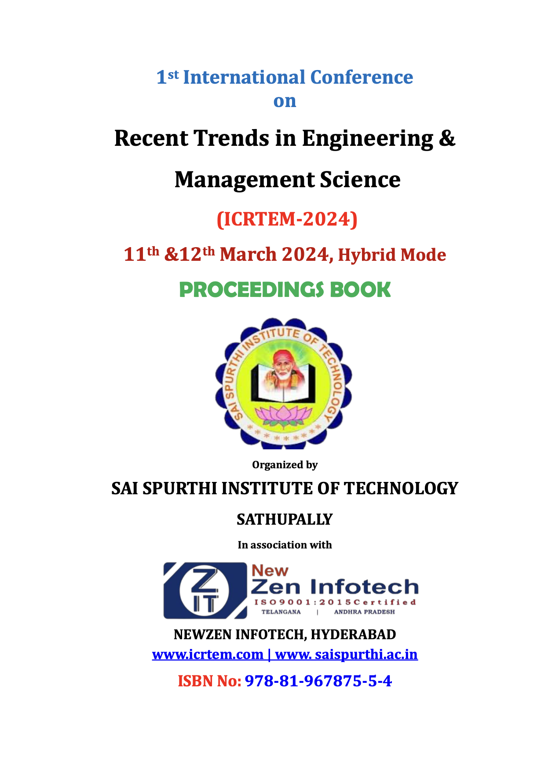

CMRCET B. Tech (CSE) Page No 49

Smart Link - Connecting Contracts Seamlessly using Blockchain

Proceedings of **International Conference on Recent Trends in Engineering and Management Science**

**(ICRTEM-2024), March 11th & 12th 2024**

**Paper ID: ICRTEM24_149**

**SMART LINK: CONNECTING CONTRACTS SEAMLESSLY ON THE BLOCKCHAIN**

**#1M. JASHWANTH, UG Student**

**#2 T. ROHIT, UG Student**

**#3T. SACHIT, UG Student**

**#4P. SRAVANTHI, Assistant Professor**

**Department of CSE,**

**CMR COLLEGE OF ENGINEERING & TECHNOLOGY, HYDERABAD.**

**ABSTRACT** - Security is paramount in banking systems, especially concerning sensitive user details. Breaches can lead to severe financial losses and breach of trust. Concerns arise from vulnerabilities in third-party systems, with centralized databases being susceptible to hacking and data manipulation. Block-chain offers a solution. Its decentralized, immutable ledger system cryptographically secures transactions, reducing the risk of unauthorized access and data tampering. Smart contracts automate processes, minimizing human error and malicious intervention. Block-chain encrypts and distributes sensitive information across a network, making it challenging for hackers to alter or steal data. Transparency allows users to track data flow, enhancing trust and accountability. Blockchain technology enhances banking security by mitigating third-party risks and ensuring confidentiality, integrity, and availability of user details. Its decentralized nature and cryptographic principles make it a valuable tool in the digital age. Keywords: Web3.0, Blockchain, Digital Currency, Ethereum wallet, Automated Transactions, Identity Management, Digital Asset Management, Decentralized Network, Peer-to-Peer Transactions.

E-Proceedings Book Available: [www.icrtem.com](http://www.icrtem.com/)

CMRCET B. Tech (CSE) Page No 50

Smart Link - Connecting Contracts Seamlessly using Blockchain

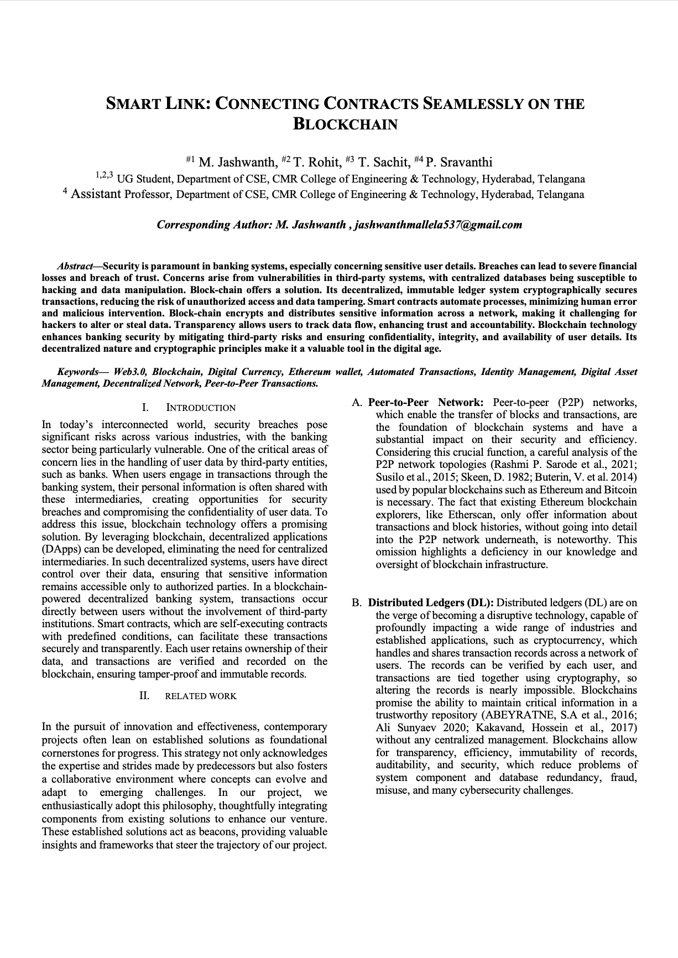

CMRCET B. Tech (CSE) Page No 51  
 Smart Link - Connecting Contracts Seamlessly using Blockchain

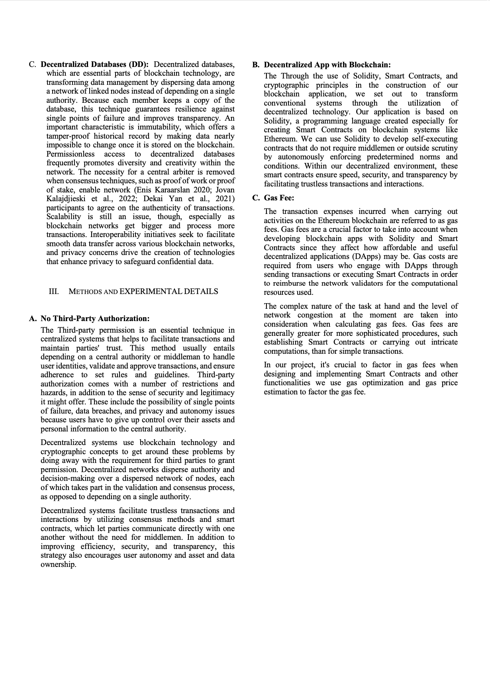

CMRCET B. Tech (CSE) Page No 52

Smart Link - Connecting Contracts Seamlessly using Blockchain

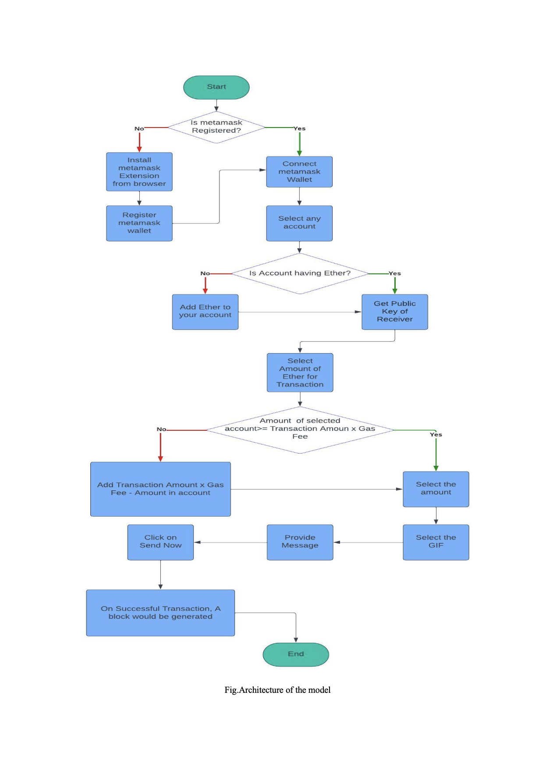

CMRCET B. Tech (CSE) Page No 53

Smart Link - Connecting Contracts Seamlessly using Blockchain

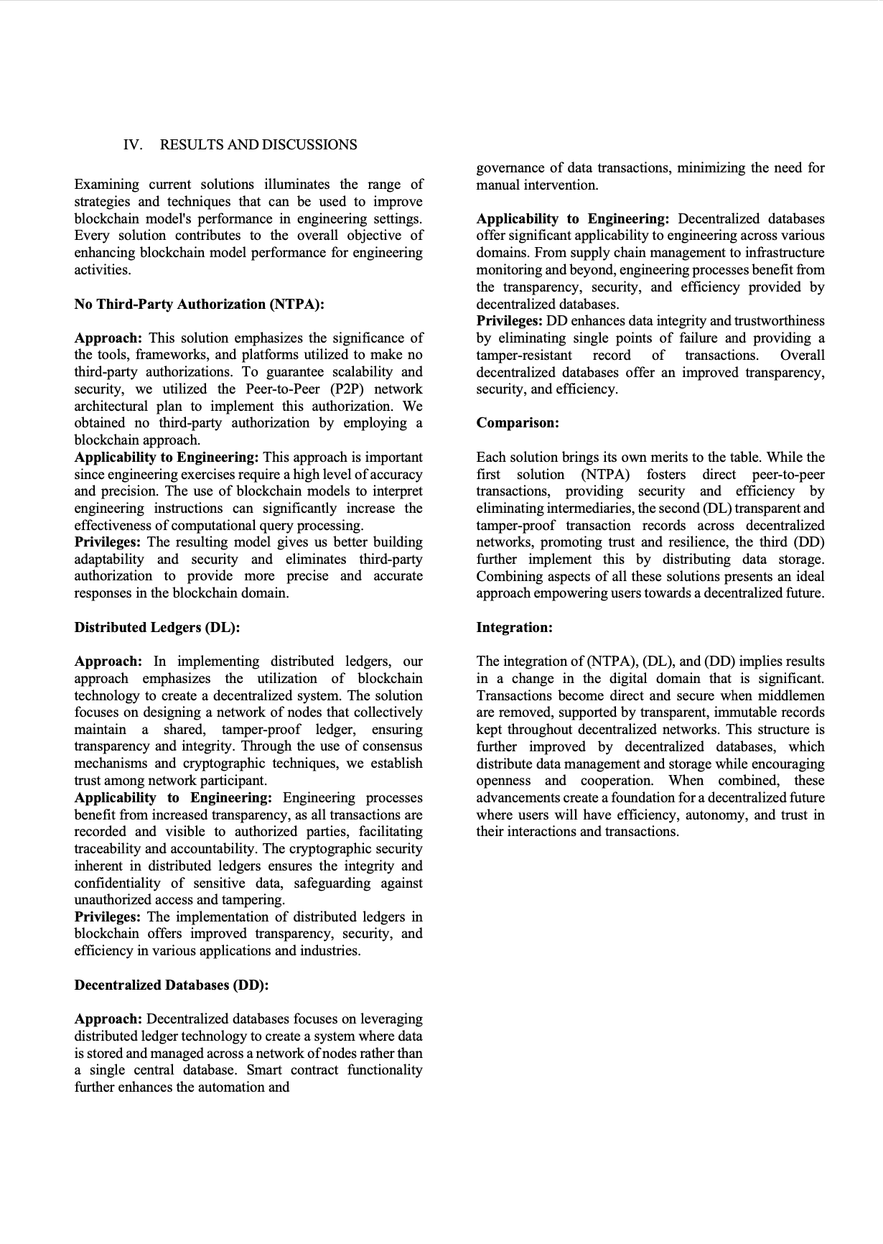

CMRCET B. Tech (CSE) Page No 54

Smart Link - Connecting Contracts Seamlessly using Blockchain

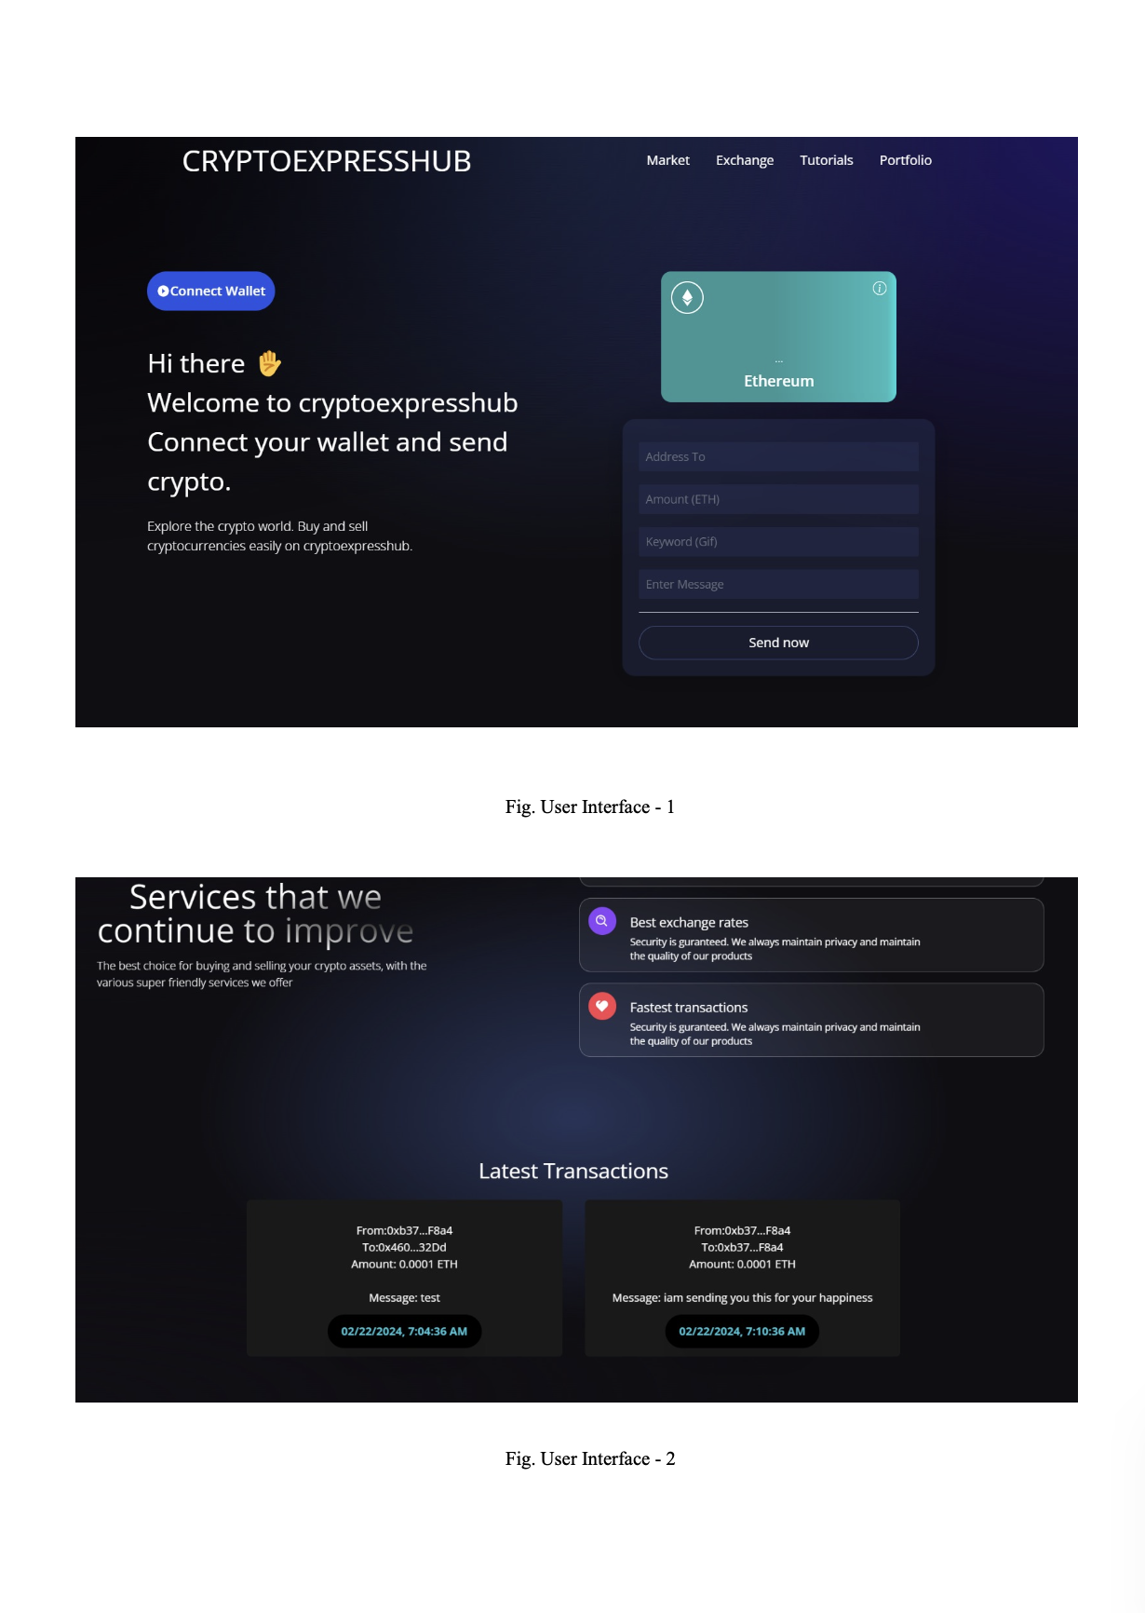

CMRCET B. Tech (CSE) Page No 55

Smart Link - Connecting Contracts Seamlessly using Blockchain

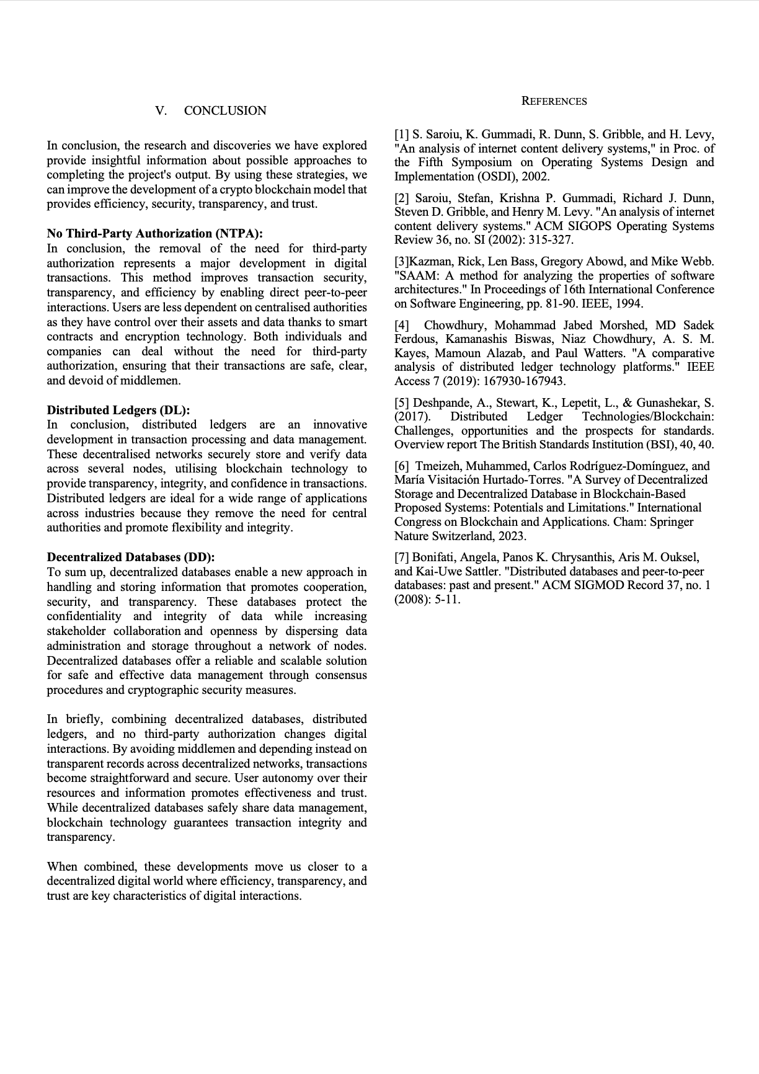

CMRCET B. Tech (CSE) Page No 56

Smart Link - Connecting Contracts Seamlessly using Blockchain

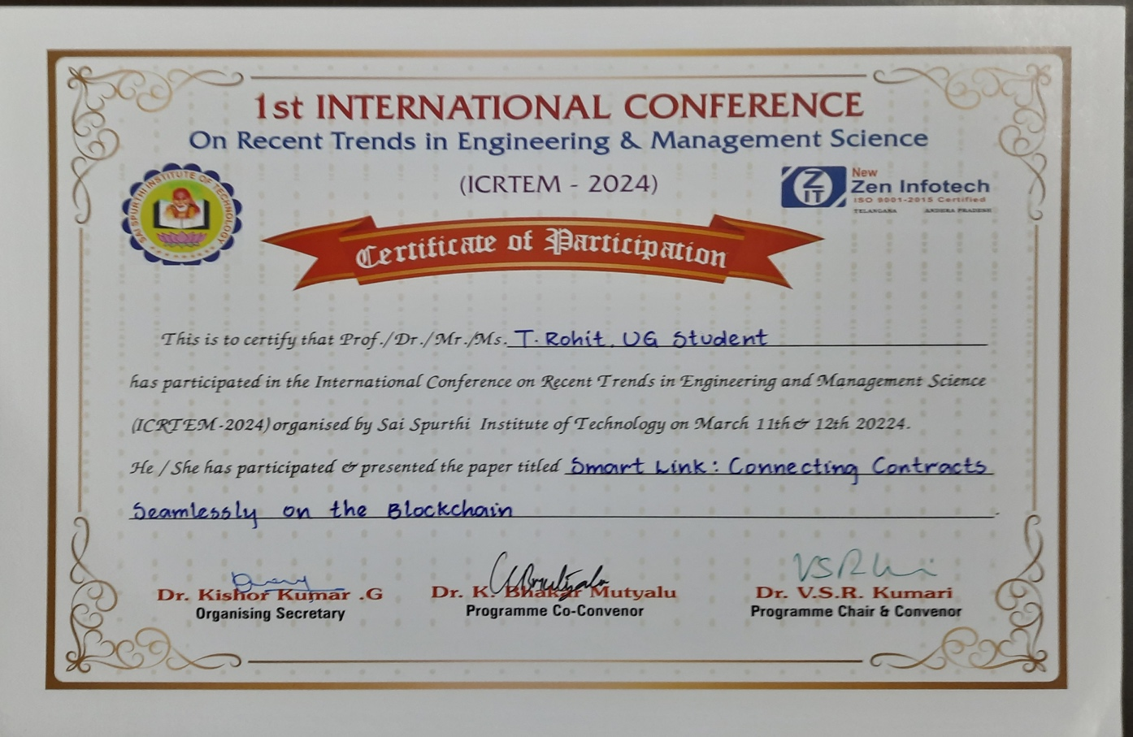

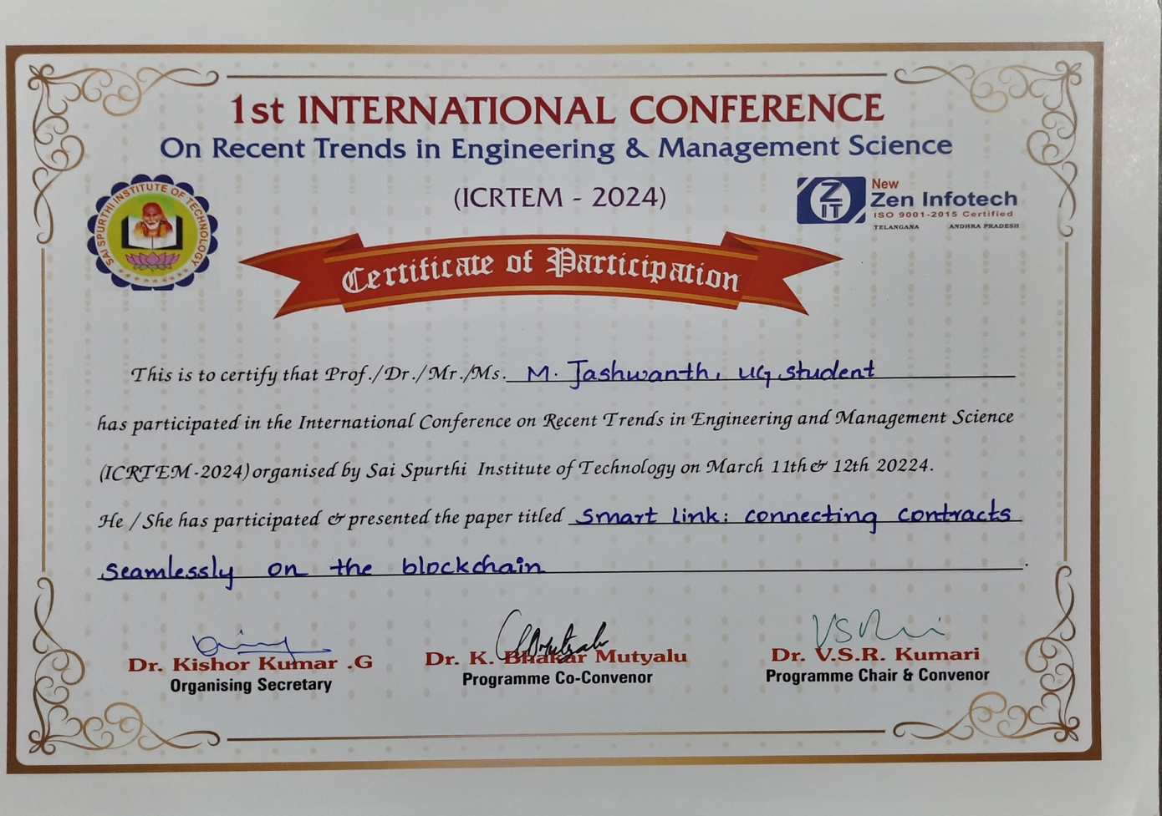

CMRCET B. Tech (CSE) Page No 57

Smart Link - Connecting Contracts Seamlessly using Blockchain

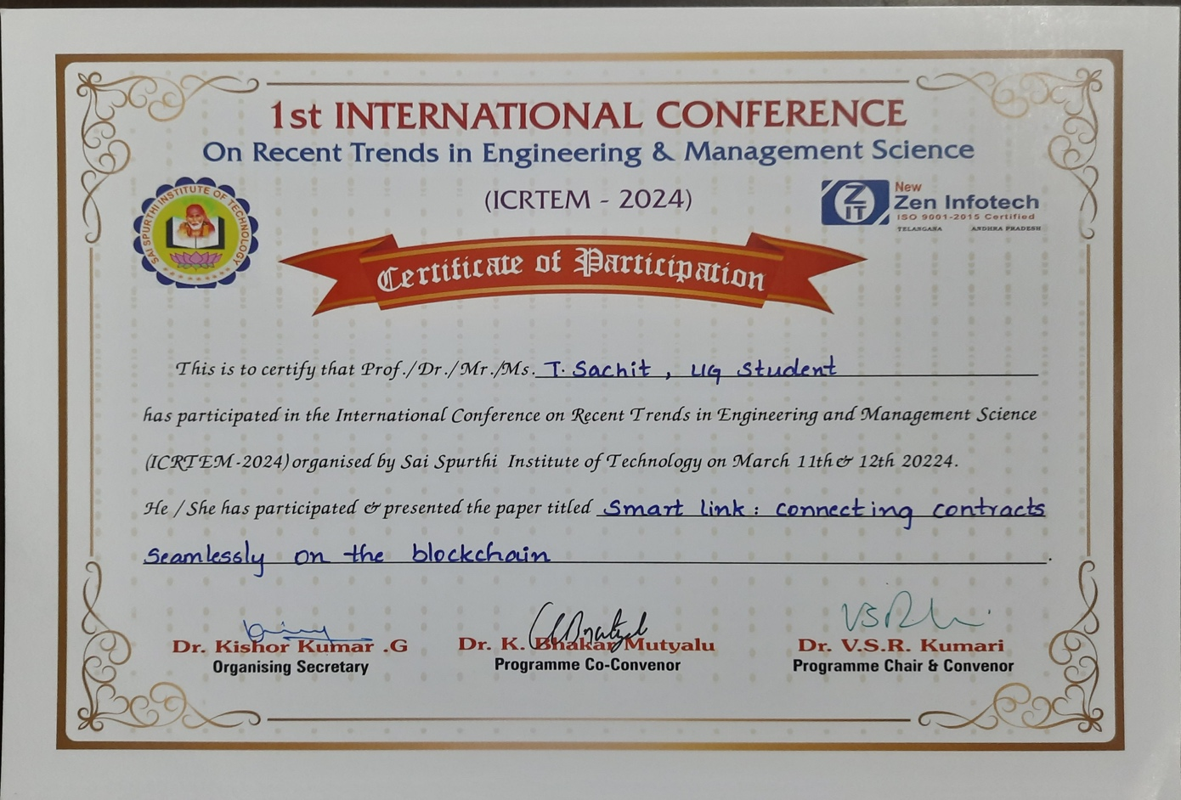

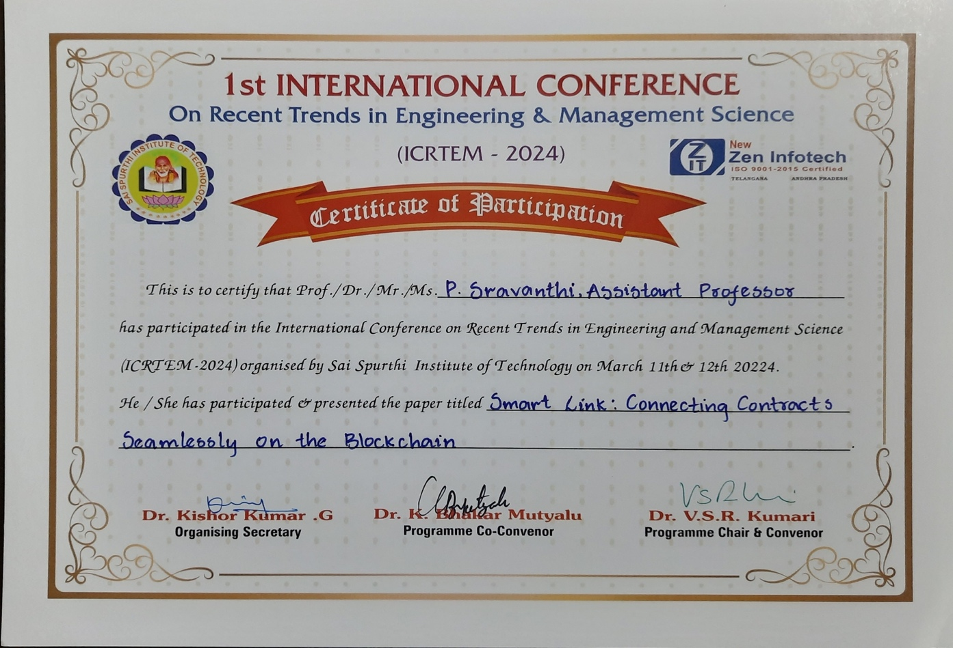

CMRCET B. Tech (CSE) Page No 58